**ASSIGNMENT 2**

**QUES 1**

<https://www.programiz.com/online-compiler/5rlj3LpVk49Os>

#include <stdio.h>

int main()

{

//ques1

int marks[5]={67,75,86,69,92};

for(int i=0;i<5;i++)

{

marks[i]+=5;

printf("New Marks=%d\n",marks[i]);

}

return 0;

}

**QUES 2**

<https://www.programiz.com/online-compiler/378UCx1QiOYEa>

#include <stdio.h>

int main()

{

//ques2

int marks[5];

printf("Enter Marks:\n");

for(int i=0;i<5;i++)

{

scanf("%d",&marks[i]);

if(marks[i]>=75)

printf("Grade A\n");

else if(marks[i]<=74 && marks[i]>=60)

printf("Grade B\n");

else if(marks[i]<=59 && marks[i]>=40)

printf("Grade C\n");

else if(marks[i]<=40)

printf("Grade D\n");

}

return 0;

}

**QUES 3**

<https://www.programiz.com/online-compiler/3LhVkcRPZS3D1>

#include <stdio.h>

int main()

{

//ques3

int marks[15]={67,75,86,69,92,46,99,72,25,86,90,54,76,75,99};

for(int i=0;i<15;i++)

{

if(marks[i]==99)

{

printf("First 99 found at index:%d",i);

break;

}

}

return 0;

}

**QUES 4**

<https://www.programiz.com/online-compiler/2P71aQOAVlDfI>

#include <stdio.h>

int main()

{

//ques4

int marks[5], name[5], count=0;

printf("Enter Name and Marks:\n");

for(int i=0;i<5;i++)

{

scanf("%s",&name[i]);

scanf("%d",&marks[i]);

}

printf("Students who have scorred 99 are:\n");

for(int i=0;i<5;i++)

{

if(marks[i]==99)

{

printf("Student %d \n",i+1);

count++;

}

}

printf("No. of Students who have scorred 99 are:%d",count);

return 0;

}

**QUES 5**

<https://www.programiz.com/online-compiler/9rljJWBAs4ZGG>

#include <stdio.h>

int main()

{

//ques5

int sum=0;

int marks[5]={67,75,86,69,92};

for(int i=0;i<5;i++)

{

sum+=marks[i];

}

printf("SUM=%d",sum);

return 0;

}

**QUES 6**

<https://www.programiz.com/online-compiler/8CcHmnZDupVE0>

#include <stdio.h>

int main()

{

//ques6

int sum=0,avg;

int marks[5]={67,75,86,69,92};

for(int i=0;i<5;i++)

{

sum+=marks[i];

}

avg=sum/5;

printf("AVG=%d",avg);

return 0;

}

**QUES 7**

<https://www.programiz.com/online-compiler/6dsxNNL4oh1Ki>

#include <stdio.h>

int main()

{

//ques7

int marks[5]={67,75,86,69,92};

for(int i=0;i<5;i++)

{

if(marks[i]%2==0)

printf("Score %d is Even\n",marks[i]);

else

printf("Score %d is odd\n",marks[i]);

}

return 0;

}

**QUES 8**

<https://www.programiz.com/online-compiler/6Hd5kIrFwL6rP>

#include <stdio.h>

int main()

{

//ques8

int marks[5]={67,75,86,69,92};

int max=marks[0],min=marks[0];

for(int i=0;i<5;i++)

{

if(marks[i]>=max)

max=marks[i];

else if(marks[i]<=min)

min=marks[i];

}

printf("Maximum marks=%d\n",max);

printf("Minimum marks=%d\n",min);

return 0;

}

**QUES 9**

<https://www.programiz.com/online-compiler/0CcHmgkb3p5mu>

#include <stdio.h>

int main()

{

//ques9

int marks[5]={67,75,86,69,92};

printf("Peak Elements are:\n");

if(marks[0]>=marks[1])

printf("%d\n",marks[0]);

if(marks[4]>=marks[3])

printf("%d\n",marks[4]);

for(int i=0;i<5;i++)

{

if(marks[i]>=marks[i-1] && marks[i]>=marks[i+1])

printf("%d\n",marks[i]);

}

return 0;

}

**QUES 10**

<https://www.programiz.com/online-compiler/8ZzySqEX0c4fF>

#include <stdio.h>

int main()

{

//ques10

int count=0;

int a[5]={67,75,86,69,92};

printf("Prime Numbers are:\n");

for(int i=0;i<5;i++)

{

for(int j=2;j<a[i];j++)

{

if(a[i]%j==0)

count++;

}

if (count==0)

printf("%d\n",a[i]);

}

return 0;

}

**QUES 11**

<https://www.programiz.com/online-compiler/0sFPwUAuQI6JR>

#include <stdio.h>

int main()

{

//ques11

int p,n,x;

printf("Enter the number of Elements:\n");

scanf("%d",&n);

int a[n+1];

printf("Enter the Elements of the Array:\n");

for(int i=0;i<n;i++)

{

printf("Element %d ",i+1);

scanf("%d",&a[i]);

}

printf("Enter the position at which new element has to be inserted and the value of element respectively:\n");

scanf("%d",&p);

scanf("%d",&x);

for(int i=n;i>=p-1;i--)

{

a[i+1]=a[i];

}

a[p-1]=x;

for(int i=0;i<n+1;i++)

{

printf("Element %d= %d\n",i+1,a[i]);

}

return 0;

}

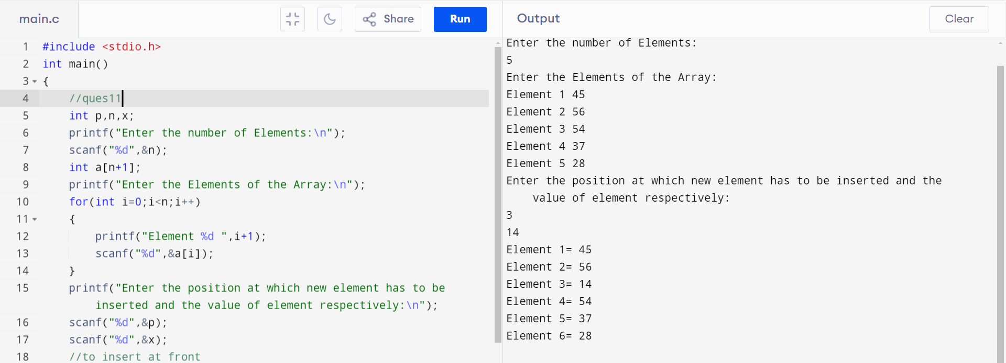

**QUES 12**

<https://www.programiz.com/online-compiler/92Es5OVR2fyUH>

#include <stdio.h>

int main()

{

//ques13

int p,n;

printf("Enter the number of Elements:\n");

scanf("%d",&n);

int a[n];

printf("Enter the Elements of the Array:\n");

for(int i=0;i<n;i++)

{

printf("Element %d ",i+1);

scanf("%d",&a[i]);

}

printf("Enter the position at which a element has to be deleted:\n");

scanf("%d",&p);

for(int i=p-1;i<=n-1;i++)

{

a[i]=a[i+1];

};

for(int i=0;i<n-1;i++)

{

printf("Element %d= %d\n",i+1,a[i]);

}

return 0;

}

**QUES 13**

<https://www.programiz.com/online-compiler/53aDRA5GXJBFh>

#include <stdio.h>

int main()

{

//ques13

int p,n;

printf("Enter the number of Elements:\n");

scanf("%d",&n);

int a[n];

printf("Enter the Elements of the Array:\n");

for(int i=0;i<n;i++)

{

printf("%d: ",i+1);

scanf("%d",&a[i]);

}

int l=a[n-1];

for(int i=n;i>=0;i--)

{

a[i]=a[i-1];

}

a[0]=l;

printf("New Array after Rotation:\n");

for(int i=0;i<n;i++)

{

printf("%d: %d\n",i+1,a[i]);

}

return 0;

}

**QUES 14**

<https://www.programiz.com/online-compiler/9fkIVpSAJyBpV>

#include <stdio.h>

int main()

{

//ques14

int count=0;

int a[15]={67,69,86,69,92,45,34,62,86,56,72,92,35,66,45};

printf("the Duplicate Elements are:\n");

for(int i=0;i<15;i++)

{

for(int j=0;j!=i;j++)

{

if(a[j]==a[i])

printf("%d,",a[j]);

}

}

return 0;

}

